### **Communities**

**Question 1**:

For the following graph:

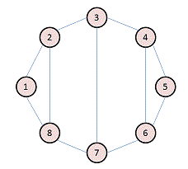

Write the adjacency matrix A, the degree matrix D, and the Laplacian matrix L. For each, find the sum of all entries and the number of nonzero entries.

**Adjacency Matrix A:**

|  |  |  |  |  |  |  |  |  |
| --- | --- | --- | --- | --- | --- | --- | --- | --- |
|  | 1 | 2 | 3 | 4 | 5 | 6 | 7 | 8 |
| 1 | 0 | 1 | 0 | 0 | 0 | 0 | 0 | 1 |
| 2 | 1 | 0 | 1 | 0 | 0 | 0 | 0 | 1 |
| 3 | 0 | 1 | 0 | 1 | 0 | 0 | 1 | 0 |
| 4 | 0 | 0 | 1 | 0 | 1 | 1 | 0 | 0 |
| 5 | 0 | 0 | 0 | 1 | 0 | 1 | 0 | 0 |
| 6 | 0 | 0 | 0 | 1 | 1 | 0 | 1 | 0 |
| 7 | 0 | 0 | 1 | 0 | 0 | 1 | 0 | 1 |
| 8 | 1 | 1 | 0 | 0 | 0 | 0 | 1 | 0 |

Sum of all entries = 22

No. of non-zero entries = 22

**Degree Matrix D:** D[i, j] = {degree($V_{i}$), if i==j; 0 otherwise}

|  |  |  |  |  |  |  |  |  |
| --- | --- | --- | --- | --- | --- | --- | --- | --- |
|  | 1 | 2 | 3 | 4 | 5 | 6 | 7 | 8 |
| 1 | 2 | 0 | 0 | 0 | 0 | 0 | 0 | 0 |
| 2 | 0 | 3 | 0 | 0 | 0 | 0 | 0 | 0 |
| 3 | 0 | 0 | 3 | 0 | 0 | 0 | 0 | 0 |
| 4 | 0 | 0 | 0 | 3 | 0 | 0 | 0 | 0 |
| 5 | 0 | 0 | 0 | 0 | 2 | 0 | 0 | 0 |
| 6 | 0 | 0 | 0 | 0 | 0 | 3 | 0 | 0 |
| 7 | 0 | 0 | 0 | 0 | 0 | 0 | 3 | 0 |
| 8 | 0 | 0 | 0 | 0 | 0 | 0 | 0 | 3 |

Sum of all entries = 22

No. of Non-Zero entries = 22

**Laplacian Matrix L:**

L [i, j] = $\left\{\begin{aligned}degree \left(V_{i}\right), if i==j \\ -1, if i≠j and V_{i} is adjacent to V_{j} \\ 0, else\end{aligned}\right.$

And also L = D – A

|  |  |  |  |  |  |  |  |  |
| --- | --- | --- | --- | --- | --- | --- | --- | --- |
|  | 1 | 2 | 3 | 4 | 5 | 6 | 7 | 8 |
| 1 | 2 | -1 | 0 | 0 | 0 | 0 | 0 | -1 |
| 2 | -1 | 3 | -1 | 0 | 0 | 0 | 0 | -1 |
| 3 | 0 | -1 | 3 | -1 | 0 | 0 | -1 | 0 |
| 4 | 0 | 0 | -1 | 3 | -1 | -1 | 0 | 0 |
| 5 | 0 | 0 | 0 | -1 | 2 | -1 | 0 | 0 |
| 6 | 0 | 0 | 0 | -1 | -1 | 3 | -1 | 0 |
| 7 | 0 | 0 | -1 | 0 | 0 | -1 | 3 | -1 |
| 8 | -1 | -1 | 0 | 0 | 0 | 0 | -1 | 3 |

Sum of all entries = 0

No. of Non-Zero entries = 30

**Question 2**:

Consider the following undirected graph (i.e., edges may be considered bidirectional):

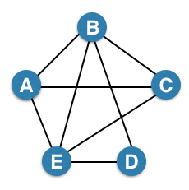

Run the "trawling" algorithm for finding dense communities on this graph and find all complete bipartite subgraphs of types K3,2 and K2,2. Note: In the case of K2,2, we consider {{W, X}, {Y, Z}} and {{Y, Z}, {W, X}} to be identical.

Adjacency List:

A = {B, C, E}

B = {A, C, D, E}

C = {A, B, E}

D = {B, E}

E = {A, B, C, D}

Complete bipartite graphs

: {{A, C, D}, {B, E}}

: {{A, E}, {B, C}}

{{A, C}, {B, E}}

{{A, D}, {B, E}}

{{C, D}, {B, E}}

{{A, B}, {C, E}}

{{B, E}, {C, D}}

**Question 3**:

We fit AGM to the network on the left, and found the parameters on the right:

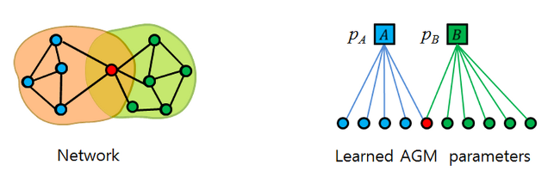

Find the optimal values for pA and pB.

After examining the AGM network and the parameters figure, we can say that

pA = 0.4

pB = 0.6 would be the optimal values